My School Online Students
Access the cards on the BPMS website and return them to the school by mail, email, or drop off in the front office.

Completed forms can be emailed to: vbodden@pasco.k12.fl.us
Or mailed to: Bayonet Point Middle School
11125 Little Road
New Port Richey, FL 34654

Current BPMS MSO Students can also submit their course cards through myLearning:
- Go to myPascoConnect
- Open myLearning
- Go to COURSES, then ALL COURSES
- Look for course:
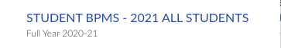
- Choose the assignment for your grade level and submit your course card.
