2020-2021
Collective Responsibility: Keeping our Students, Staff, & Families Safe
School safety is a collective responsibility and it will take efforts of all of our Patriot students, staff and families to keep Bayonet Point clean and safe.

GENERAL FACILITIES  - Face coverings are to be worn during all times students/staff are traveling in/out of the building, passing times, cafeteria when not eating, classroom unless otherwise instructed based on the activity and ability to appropriately distance from others.  - The campus will open at 8:10AM. ALL students enter through the back of the school by the gym. They will get breakfast from the cart (if desired) and will go directly to their 1st period class.  - Increased supervision of staff to support students social distancing and not congregating.  - Staggered dismissal so that students can distance themselves leaving the building at the end of the school day.  - Water bottle refill station/water fountains are located in the Commons & hallways. Students encouraged to have their own bottle.  - 8 hand sanitizer stations located around the building and in each classroom.  - Soap and automatic dryers available in all bathrooms.  - Enhanced weekly cleaning of walls, cabinets, furniture and floors.  - Increased frequency of changing AC filters.  - Increased cleaning and disinfecting of the facilities at night.  - High traffic and frequently touched areas such as bathrooms and hallways will be routinely cleaned and disinfected throughout the day.  - Every staff member completed training prior to school starting that promotes awareness, knowledge and skills about mental health and suicide preventions and prepares staff to facilitate conversations when students are in distress and connect them with support.  - Isolation area in the clinic for symptomatic students.  Signage and Safety Reminders  Signage in bathrooms, commons areas, and hallways promoting health and safety practices.  Bulletin boards around the building sharing how Patriots reinforce healthy hygiene and expected school and workplace behaviors.  Visitors & Office Areas  Visitors will not be permitted on campus for meetings and/or lunch from August to December at this time.  No more than 2 students are permitted in the front office lobby at one time and only 1 visitor or family in the lobby at one time.  Meetings with school staff are by appointment only. | CLASSROOMS  - Students are HIGHLY encouraged to bring their own supplies to support students having their own belongings vs. community supplies. Personal supplies to consider, but are not limited to hand sanitizer, calculators, water bottles, technology (tablets, laptops, cellphones), and class materials.  - It is recommended that students will use hand sanitizer upon entering and exiting the classroom.  - Students will keep all of their belongings, including backpacks, with them at all times to avoid any cross-contamination.  - Classrooms will be designed to assist with social distancing by spacing out desks and tables.  - PE locker room and lockers will not be used for classes and dressing out for PE will not be encouraged. Students should dress in athletic wear to school on activity days.  - PE lockers will only be sold to current athletes to store athletic equipment during the day before practice.  - Each classroom will have a “Sanitation Station”. These stations will consist of hand sanitizer, disinfectant spray and micro-fiber & paper towels that will be replaced daily.  - While in class, teacher will have procedures for social distancing and how to clean/disinfect any materials needed for the lesson.  - Students will have access to resources and coursework online. It is recommended that assignments and assessments be administered or turned in online to avoid having physical documents to contaminated. Students can use phones to take pictures of assignments and turn them in.  - There will be a designated time at the end of the class for cleaning and disinfecting the classroom to prepare for the next class.  - Technology in labs, carts and classrooms will be appropriately disinfected after use.  - Activities the first weeks of school for Traditional and mySchool students to support their Social Emotional Learning and re-acclimating to a “new normal.”  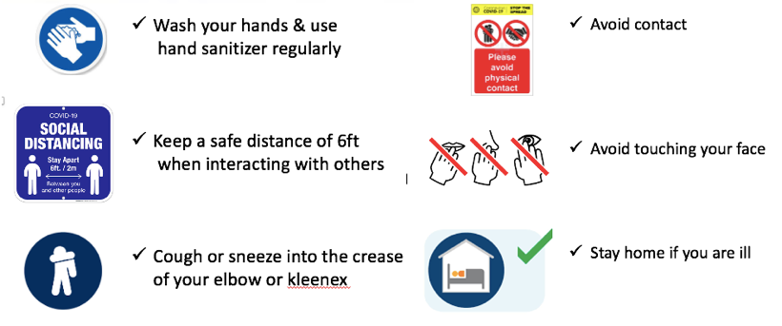
CAFETERIA (BREAKFAST & LUNCH)  Breakfast  In the morning, all students may go to the breakfast cart at the back of the school and then go immediately to their first period class with their “grab and go” meal choice.  Transition to and from Lunch  - Students will bring their backpacks with them as they are escorted by staff.  - Students will find their designated eating area either inside, outside and wait to be dismissed by an adult to get their food.  - Once dismissed, students will sanitize their hands before getting lunch.  - Students will dispose of their waste in the trash cans.  - Students will wait to be dismissed by staff from lunch.  - Students will wear their masks and ensure social distancing.  Lunch  To accommodate large crowds while adhering to physical distancing guidelines, we will implement the following practices during student lunch times of the day:  - Reduced cafeteria seating to less than 50%.  - Tables are separated with only 3 students allowed to sit at each table.  - Added a third seating area for lunch – outside seating.  - Provide hand sanitizer stations in locations where hand washing is not practical or permissible (entrances of the cafeteria and food lines).  - Students are to remain seated at all times and must raise their hands to go to food lines, snack shack vending machine and restrooms.  - Ensure cafeteria restrooms have adequate hand soap and supplies to allow for vigorous hand washing.  - Cafeteria seating and tables will be sanitized between all lunch periods.  - More frequent sanitization on high touch points in the serving line and throughout the cafeteria.  - Adjust feeding patterns to limit the number of students in line at the same time so the physical distancing can take place.  - All food purchases will be packaged for safety. All utensils and condiments will be individually packaged.  - Place appropriate educational signage to communicate best practices around physical distancing and personal hygiene.  - Provide additional adult supervision. | TRANSITIONS (ARRIVAL, PASSING, DISMISSAL)  Arrival  - The campus will open at 8:10AM. Buses will be released in a staggered time frame to minimize number of students entering the school.  - Students enter through the back of the school. They will get “grab and go” breakfast from the cart (if desired) and will go directly to their 1st period class.  - Signage will be placed to establish a one-way flow for arrival and dismissal.  - Students may not congregate outside or in other areas of the campus.  Passing  - Hallways will be one way only where possible to allow students to “stay to the right” when moving through the buildings.  - Signs will be posted around campus reminding students to wear their masks, socially distance, and to follow the traffic flow.  - There will also be increased supervision to assist in limiting congregation and to provide support for a smooth transition.  Dismissal  - There will be a staggered dismissal so that students can distance themselves leaving the building at the end of the school day. Students will be dismissed by grade level starting with 6th Grade.  - Increased supervision of staff to support students social distancing and not congregating.  - Students will exit through the rear doors of the school (bus riders) and front of the building (car riders) to assist with social distancing and congregating. Walkers and Bike Riders have designated areas to report to until it is safe for them to leave. The campus will close to students who are not participating in extra-curricular activities at 3:38PM.
How can families support these efforts?

Bring personal hand sanitizer

Bring a reusable water bottle

Wash your masks regularly

Sanitize/wash your lunchbox and backpack

Wash your hoodies and sweaters

Wear a mask

Wash your hands
- Screening your child each day for a temperature or sickness

Use your own supplies

Bring your own electronic device (laptop, tablet, iPad)

