2020– 2021 Bell Schedule

**Note: Our bell schedule is a 6-day continuous rotation. Updated July 2020.**

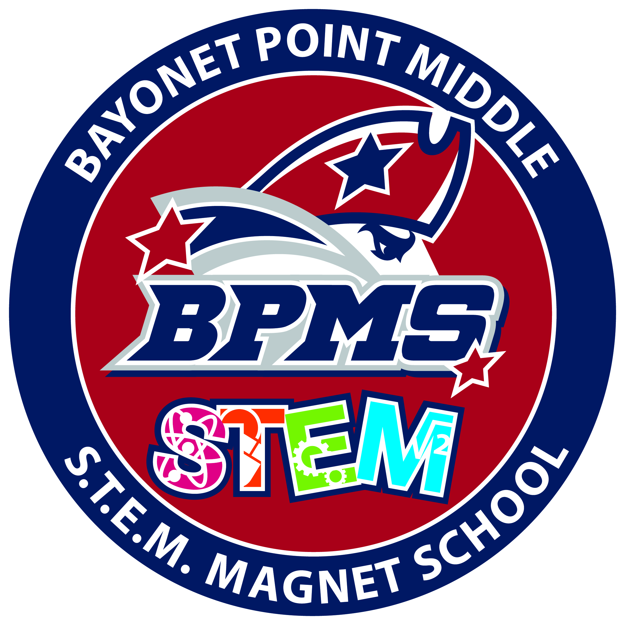

­

|  |  |  |  |  |  |  |
| --- | --- | --- | --- | --- | --- | --- |
|  | **Red Day** | **Orange Day** | **Yellow Day** | **Green Day** | **Blue Day** | **Purple Day** |
| 8:30 – 9:54 | 1st | 3rd | 5th | 6th | 2nd | 4th |
| 9:57 – 10:50 | 2nd | 1st | 6th | 5th | 6th | 1st |
| **“A” Lunch Schedule:**  Lunch 10:53 – 11:23  Class 11:26 – 12:19  Class 12:22 – 1:15  **“B” Lunch Schedule:**  Class 10:53 – 11:46  Lunch 11:49 – 12:19  Class 12:22 – 1:15  **“C” Lunch Schedule:**  Class 10:53 – 11:46  Class 11:49 – 12:42  Lunch 12:45 – 1:15 | “A” lunch  10:53 – 11:23 | “A” lunch  10:53 – 11:23 | “A” lunch  10:53 – 11:23 | “A” lunch  10:53 – 11:23 | “A” lunch  10:53 – 11:23 | “A” lunch  10:53 – 11:23 |
| 3rd | 2nd | 3rd | 3rd | 3rd | 2nd |
| “B” Lunch  11:49 – 12:19 | “B” Lunch  11:49 – 12:19 | “B” Lunch  11:49 – 12:19 | “B” Lunch  11:49 – 12:19 | “B” Lunch  11:49 – 12:19 | “B” Lunch  11:49 – 12:19 |
| 4th | 5th | 4th | 4th | 4th | 5th |
| “C” Lunch  12:45 – 1:15 | “C” Lunch  12:45 – 1:15 | “C” Lunch  12:45 – 1:15 | “C” Lunch  12:45 – 1:15 | “C” Lunch  12:45 – 1:15 | “C” Lunch  12:45 – 1:15 |
| 1:18 – 2:11 | 5th | 6th | 1st | 2nd | 1st | 6th |
| 2:14 – 3:08 | 6th | 4th | 2nd | 1st | 5th | 3rd |
| I EAT (1st Semester) |  |  |  |  |  |  |
| I EAT (2nd Semester) |  |  |  |  |  |  |