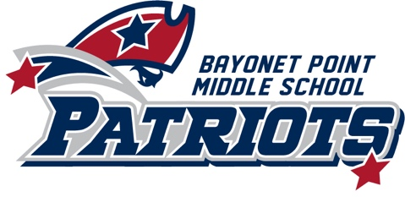
Bayonet Point Middle School
(2020 – 2021)
Title I Parent Involvement Plan

Our Mission Statement
Reaching every student every day.

Our Vision Statement
Empowering tomorrow's problem solvers to change the world.

Title I School and Families
Bayonet Point Middle School will involve families in the development of the school’s Title I Plan and the process of school review and improvement.

Annually, Bayonet Point Middle School will convene a meeting to which parents are invited. At this meeting, the principal and staff will inform the parents of the school’s participation in Title I, explain the benefits to the families, the requirements and the rights of the parents to be involved.

Parents will be invited and encouraged to meet with their student’s teachers, attend monthly SAC meetings to offer suggestions, share experiences and to participate in decisions related to the education of their student. In addition, parents will be provided a description and explanation of the curriculum and standards used at the school, the forms of assessment used to measure student progress, and the proficiency levels students are expected to meet.

Family Involvement Options
Families will be encouraged to partner with our school by providing a supportive home environment. Based on our school’s Parents Needs Assessment, Bayonet Point will provide the following requested parent activities:

- Opportunities for volunteering
- Parent information workshops
- College Night
- Parent Teacher Conference Nights
- Parent/Teacher/Student conferences – with a focus on Student Led Conferences
- School surveys to determine needs of school families
- Parent Satisfaction Evaluations for individual school events

We know that families are available on different days and different times schedules. Therefore, Bayonet Point will accommodate our families’ schedules by providing flexible dates and times when planning family events.

Communication
Bayonet Point is committed to provide their families consistent and timely communication. Families will be informed of school events, volunteer opportunities, and student specific information through various types of communication during the school year.

- School Messenger (phone messages – a minimum of one every week with updates)
- School website
- myStudent (Grades, Attendance, Test Scores, Progress Reports, & Report Cards)
- Positive phone calls home
- Emails
- Flyers
- School Marquis
- Social Media (Facebook, Twitter, & Instagram)

Bayonet Point Middle School will partner with our families using a home and school compact. The compact will specify the expectations and goals for the student, family, and school. These expectations will provide a meaningful school experience with positive student achievement.

Annually, The School Advisory Council will review and make recommendations for the Parent Involvement Plan, and the Home and School Compact. Families are encouraged to submit their feedback regarding individual school events and Parent Involvement Plan and to participate in our annual needs assessment survey.

For more parent resources, parents may contact the PIRC-Parent Information & Resource Center at USF by calling: (813) 974-5458, or at the website, http://www.floridapartnership.usf.edu/ for more information.

Parents can also reach out to our School Counselors, Ms. Torres (ktorres@pasco.k12.fl.us) or Mrs. Davies (ddavies@pasco.k12.fl.us) or calling our main line at (727) 774-7400.

This document will be made available to all parents annually. In carrying out the requirements of this plan, Bayonet Point shall provide full opportunities for the participation of parents with children with limited English proficiency, parents with children with disabilities, and parents of migratory children. This includes providing information and school reports in a format, and to the extent practical, in a language such parents can understand.

Information will be provided in Spanish when needed. Si necisita ayuda para entender esta informacion, por favor contact a su escuela.

