Arrival | MySchool Online | Traditional | Dismissal
BUS RIDER:  I will wear a face covering such as a mask on the bus.  I will sit with a consistent friend and sibling/family member.  I will social distance as I walk to the back of the building or wear my mask.  I will enter through the back of the school, sanitize my hands and go straight to the breakfast area in the Commons. If I am not taking a breakfast, I will go straight to my first class of the day.  CAR RIDER:  I will be dropped off in front of the Band building no earlier than 8:10 AM and walk to the back of the building.  I will social distance as I walk to the back of the building or wear my mask.  I will enter through the back of the school, sanitize my hands and go straight to the breakfast area in the Commons. If I am not taking a breakfast, I will go straight to my first class of the day.  WALKER/BIKE RIDER:  I will arrive on campus between 8:20 AM & 8:25 AM.  If I ride a bike, I will lock it up in the bike rack located in the front of the school.  I will enter through the back of the school, sanitize my hands and go straight to the breakfast area in the Commons. If I am not taking a breakfast, I will go straight to my first class of the day. | I will have my workspace ready and be logged in online at 8:30AM  I will check my announcements for each class on myLearning.  I will set a timer for my scheduled 30-minute lunch time.  I will attend all classes and required Zoom sessions.  I will check my messages daily on both myLearning and Outlook (Office 365).  I will use a planner, calendar or other organizational tool to record assignments.  I will work productively and post my own work. I will safely explore the internet and be responsible for my posts.  I will end my day by making a list of homework and things to do to be prepared for the next day.  I will reach out to my teachers for support with my assignments or navigating my courses.  I will encourage my parents/guardians to establish and utilize the Parent Portal to support me in my classes weekly.  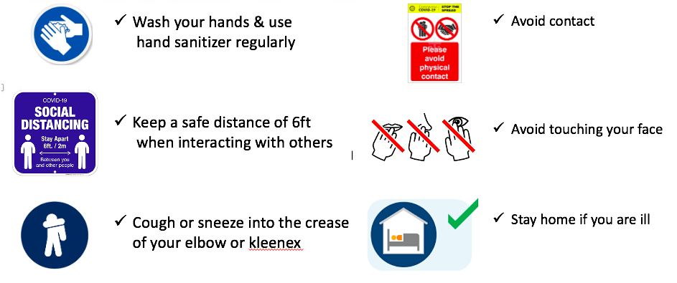 | I will wear a face covering while on any school grounds, including the bus stop.  I will responsibly sanitize my hands, enter the building safely, get my breakfast (if desired) and report straight to my first class of the day.  I will throw away my trash and sanitize my hands before and after eating.  I will not congregate in hallways or courtyards.  I will follow the directional pattern in the hallways by staying to the right.  I will wear my mask and maintain distance from my friends when walking to class.  I will sanitize my hands upon entering every classroom and cafeteria for lunch.  I will follow classroom start-up procedures and follow safety expectations.  I will be respectful and responsible in my classroom interactions.  I will wear a face covering at lunch while not eating and will social distance when possible.  I will raise my hand at lunch if I need to leave my seat.  I will use a planner, calendar or other organizational tool to record assignments.  I will report directly to the bus loop, car rider loop, or my designated area (If I am a walker or bike rider) upon dismissal, wear my face covering and social distance when possible.  I will review my planner when I get home to ensure I am prepared for the next day.  I will reach out to my teachers for support with my assignments when needed. | BUS RIDER:  I will exit the building when my Grade Level is dismissed.  I will report directly to the bus loop upon dismissal, wearing my face covering and social distancing when possible.  I will wear my mask on the bus and sit with the same people.  CAR RIDER:  I will exit the building when my Grade Level is dismissed.  I will report directly to the car rider loop upon dismissal, wearing my face covering and social distancing when possible.  I will maintain 6ft of distance (where possible) as I wait to be picked up and wear my mask.  I will safely stay in the loading zone and watch for my car to arrive.  WALKER / BIKE RIDER/ATHLETES/AFTER SCHOOL ACTIVITIES:  I will report directly to the designated waiting area for walkers, bike riders, athletes, and after school activities.  I will wear my face covering and social distance where possible.  I will maintain social distance while getting my bike or walking and immediately leave campus.  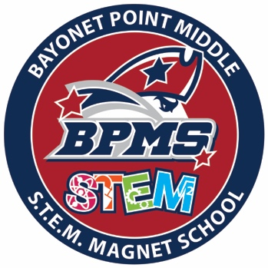
2020-2021 Bayonet Point Middle School STUDENT Expectations

