Parents and families,

Pasco County Schools is proud to offer many high-quality educational options at each of our great schools. While most students are assigned to a school based on the location of their residence, our district provides families with a variety of school choice options and programs. We encourage parents and guardians to explore all that we offer based on the unique learning needs and interests of their children.

We offer…
- Magnet schools and programs such as STEM, STEAM, Cambridge, and International Baccalaureate.
- Educational options and innovative programs such as AVID, AP Capstone, arts, career pathways, technical education, eSchool, and more.

If you are interested in applying for school choice to participate in any of our educational options, or to attend another school, please note the following timeline for submitting all school choice applications:

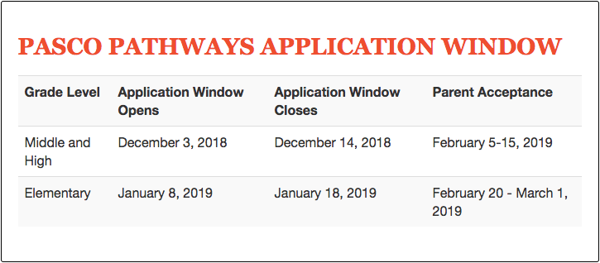

Once the application window opens, parents and students will use myStudent to complete school choice applications. You will receive several other communications throughout the fall with additional details concerning school choice. Stay tuned…

