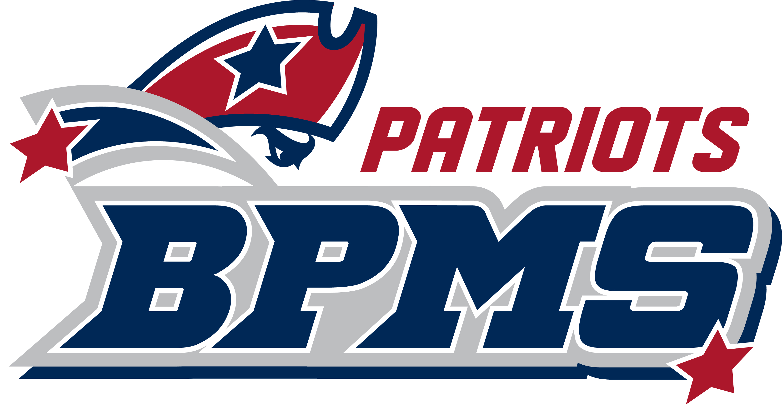
BPMS Grade 7 Common Supply List

12 Folders (2-3 per class) (any color or type is fine)
2 Composition type notebooks
1 5-subject notebook with plastic cover (science)
10 one-subject spiral bound notebooks
3 packs of Loose Leaf Paper (college ruled)
2” – 3” Binder (Civics)
5-pack dividers (Civics)
Calculator (Preferably TI-30Xa)
Pencils
Erasers (Pencil cap or hand held)
Pencil Sharpener
Red and Blue Pens
Colored Pencils
Expo markers
Glue sticks
Scissors
Highlighters (various colors)
Flash Drive (recommended)
Headphones (recommended)

Classroom needs:
Hand sanitizer
Tissues
Clorox wipes
Tape

