Bayonet Point Middle School
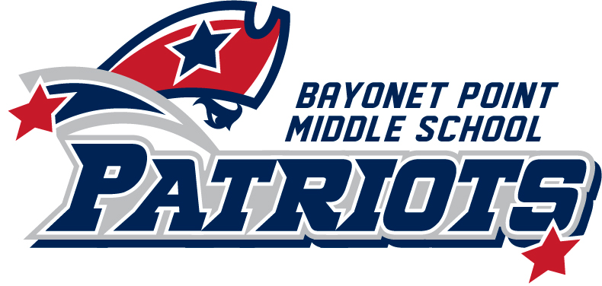

Shelley Carrino, Principal
Laura Luter, Assistant Principal
Kathryn Wild, Assistant Principal

11125 Little Road
Port Richey, FL 34668
(727) 774-7400
Fax: (727) 774-7491
http://bpms.pasco.k12.fl.us

ENGLISH FOR SPEAKERS OF OTHER LANGUAGES (ESOL)
Notification for Administration of Statewide Assessment

Your student will be participating in statewide assessment tests. Date: April 2017
Name of Test | Date(s) of Test Administration
FSA ELA Reading (Grades 4–10 Computer-Based)  FSA Mathematics (Grades 3–8 Computer-Based) | April 10–May 12, 2017
FSA EOC (Computer-Based) Algebra 1, Geometry | April 17–May 12, 2017  July 10–21, 2017
NGSSS EOC (Computer-Based Accommodations) Civics | April 17–May 19, 2017  July 10–21, 2017
NGSSS Statewide Science Assessment | May 1–5, 2017

In order to address language level needs, test accommodations will be implemented. We recommend that your student take the test with accommodations in a regular classroom. If you have any questions or concerns about this recommendation, please contact the school’s Administrative Contact for ESOL at the school.

Sincerely,
Shelley Carrino

Fecha Abril 2017

Su estudiante estará participando en pruebas a nivel de estado:
Nombre de la prueba | Fecha(s) para la administración de la prueba
FSA ELA Lectura (Grados 4–10)  FSA Matemáticas (Grados 3–8) | Abril 10–mayo 12, 2017
FSA EOC Álgebra 1, Geometría | Abril 17–mayo 12, 2017
NGSSS EOC Civismo | Abril 17–mayo 19, 2017
NGSSS Prueba a nivel de estado de Ciencias | Mayo 1–5, 2017

Se implementarán acomodaciones de modo que se puedan suplir las necesidades relacionadas al lenguaje.
Recomendamos que Su estudiante tome la prueba con acomodaciones en un salón de clases regular. Si tiene cualquier pregunta relaciona a esta recomendación, favor de llamar a la persona contacto del Programa ESOL en su escuela.

Atentamente,
Shelley Carrino

