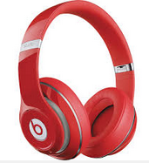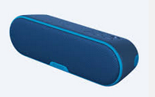

**NOTE:**

* Bluetooth/external speakers should be left at home
* Volume must be low enough to not disturb others

**Students may quietly use WCDs at the following times:**

* Before & after school
* During lunch break
* During extracurricular school activities
* At school-related functions
* Students must demonstrate integrity when using WCDs.
* Use camera features only in appropriate locations.
* Get permission from others before taking pictures or recording.
* WCDs and headphones must be turned off and stored out of sight when directed by teacher.

**Wireless Communication Device**

**Expectations**