[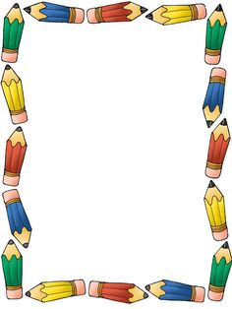](https://www.google.com/url?sa=i&rct=j&q=&esrc=s&source=images&cd=&ved=0ahUKEwib4MuvqK_NAhUKMyYKHbfODpgQjRwIBw&url=https://www.pinterest.com/pin/325455510544409240/&psig=AFQjCNEqkHTrwsRXOddePrdVeY9DhpxsHg&ust=1466261609740051)

Bayonet Point Middle School

2016 – 2017 School Supply list for all Grades

~~~~~~~~~~~~~~~~~~~~~~~~~~~~~~~~~~~~~~~

* Sturdy Backpack
* Pencils & Eraser Tops
* Pens (Blue/Black)
* Paper (Loose leaf)
* Colored Pencils
* Composition Notebook
* Spiral Notebooks – 6 for each semester
* 2 Pocket Folder w/3 prongs – 6 for each semester
* Highlighters
* Sticky Notes (3inx3in)
* Flash Drive
* Earbuds

Donations for the Classroom will also be accepted, however are not required.

* Glue Sticks
* Tissues
* Hand Sanitizer
* Baby Wipes
* Paper Towels