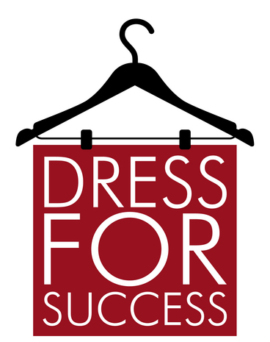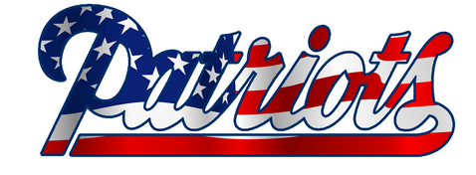

**Keep the focus on learning!**

The administration’s decision on appropriate dress is final.

**Wear modest clothing**

* Shorts/skirts no more than 4” above the

knee

* Pants worn securely at the waist

* Shirts have sleeves and cover chest/belly

* Appropriate pictures/words on clothing

**Hats and bandanas are only allowed for preapproved special school activities or religious purposes**

**Wear appropriate shoes for school**